Query the list of CITY names from **STATION** that do not start with vowels. Your result cannot contain duplicates.

**Input Format**

The **STATION** table is described as follows:

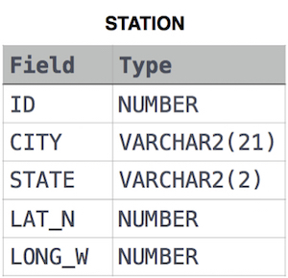

where LAT_N is the northern latitude and LONG_W is the western longitude

Solution :

SELECT DISTINCT CITY

FROM STATION

WHERE SUBSTR(CITY,1,1) NOT IN ('A','E','I','O','U','a','e','i','o','u');